Please use this template to provide feedback on the National Certificate of Capacity prototype. Feedback is specifically sought as to whether the National Certificate of Capacity prototype is suitable for the Tasmanian situation. That is, does it met the requirements of the Workers Rehabilitation and Compensation Act 1988 and the supporting systems in place in Tasmania?
Review each section below and add any feedback in the ‘Comments’ space provided. Comments for all fields below are optional.
Name:
Name of your organisation:

Header/Introductory wording
Comments:

Patient Details
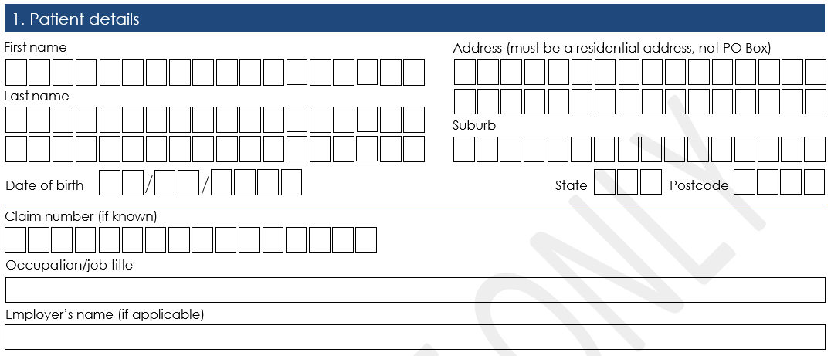
Comments:

Diagnosis
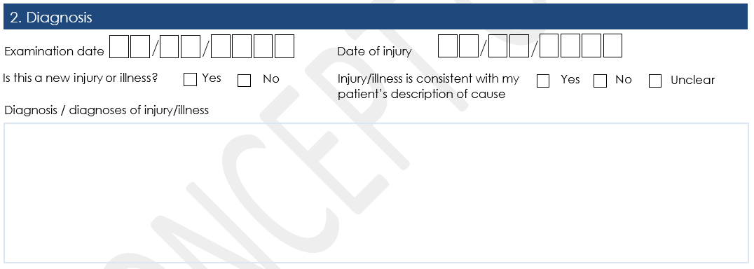
Comments:

Management Plan
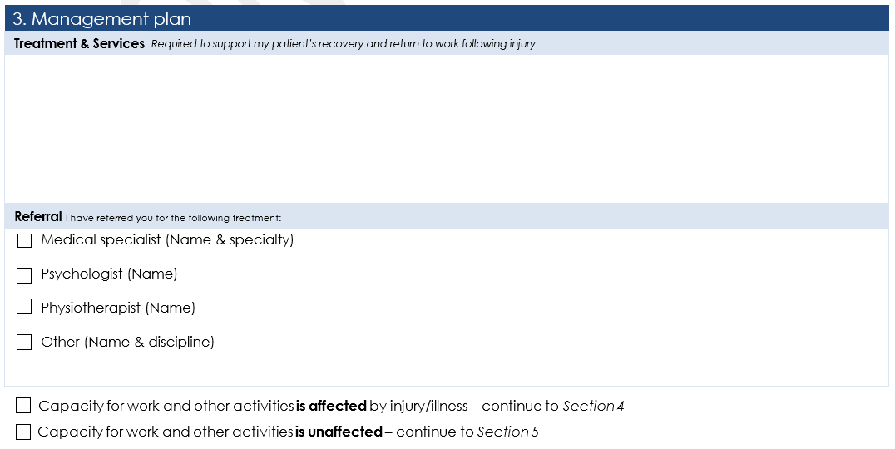
Comments:

Capacity Assessment
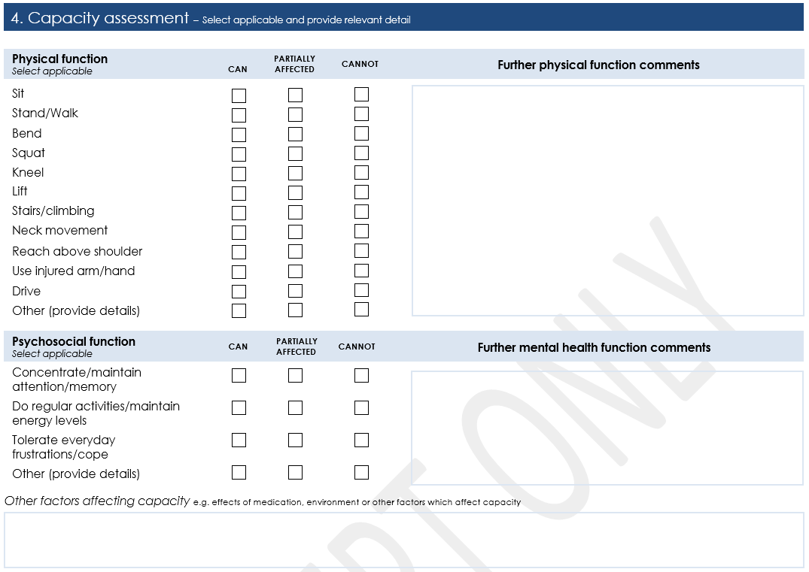
Comments:

Certification
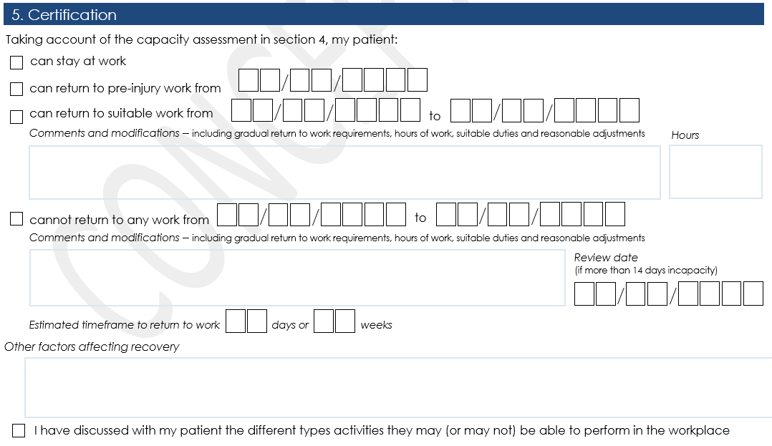
Comments:

Provider declaration
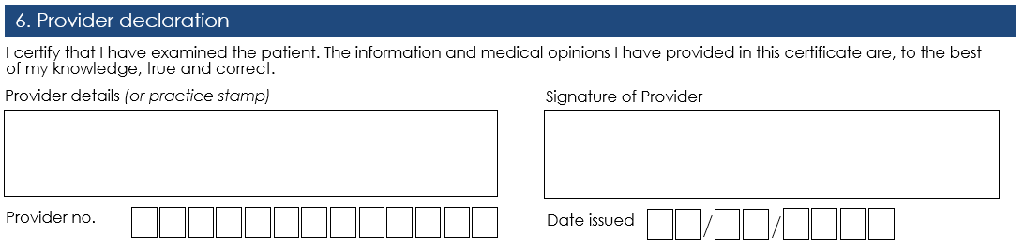
Comments:

Patient consent
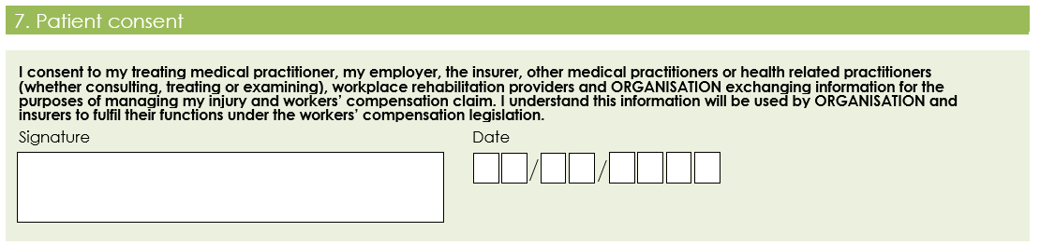
Comments:

General Comments
Comments:

Please return completed Feedback Form to damian.davidson@justice.tas.gov.au.
All feedback to be received by no later than close of business Wednesday 21 August 2019.

